Release Note (Qbuzz_release0.0.8_EAM11.7-Qbuzz- Change_Release12Dec.zip)
EAM11.7-Qbuzz
Title:  EAM11.7-Qbuzz | Date Issued  12th-Dec-2022

General comments
This implementation is based on INFOR EAM 11.7

List of observations addressed in this patch/fixes/modifications
S. No. | Description of Observation | Files
1. | EAM11.7- Qbuzz-Change_Release 12Dec | Db scripts  - SPC-296.sql  EF  - QBUZZ_external_WSJOBO.txt  - QBUZZ_external_WSTRAD.txt  - QBUZZ_external_SCHADE.txt

Pre-Installation instructions
In an effort to ensure that your INFOR EAM system continues to operate with maximum efficiency and minimal problems, Infor strongly recommends that you:
- Apply this fix to a test environment and perform your own user acceptance testing before applying this customization to your production environment.
- Db scripts can only be run when user defined screen has been generated.

Configuration Instructions
- Clone Screen: Administration→ Screen configuration→ Screen.
Screen: SCHADE

Select CSCASE from the list and copy the screen.
Screen Name | SCHADE
Description | Damage
Parent Screen Name | CSCASE

Save the record
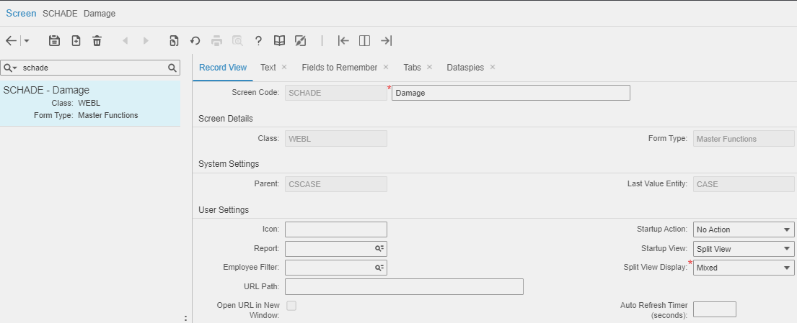

- Create User Defined Tab: Administration→ Screen configuration→ User defined screen.
Tabs: - OUCOST

Screen Name | OUCOST
Description | Additional Costs
Table Name | DMCOST
Parent Screen | SCHADE
Tab | Checked

Save the record
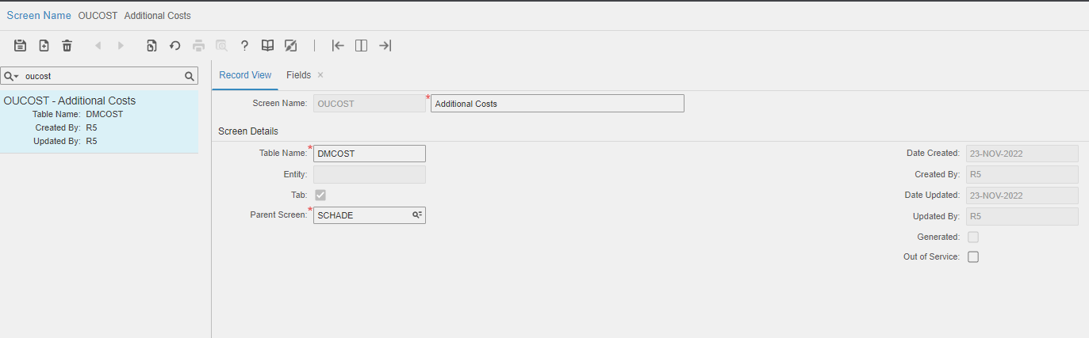
Navigation to fields
Please refer attached files for fields.

- Create User Defined Tab: Administration→ Screen Configuration→ User Defined Screen.
Tab:- OUSUTR

Screen Name | OUSUTR
Description | Supplier Trade Rates
Table Name | SUPPRATE
Parent Screen | WSTRAD
Tab | Checked

Save the record
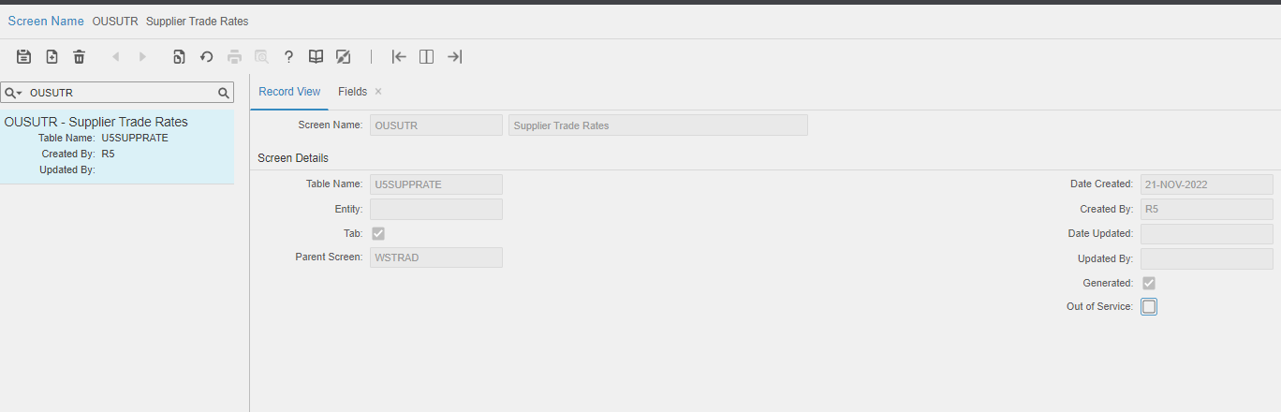
Navigation to fields
Please refer attached files for fields.

- Create types: Administration→ Set Up→ System Code.
Type:- SCH

User Code | Entity | System Code | Description
SCH | CXTP | * | Schadeafhandeling

Save the record.
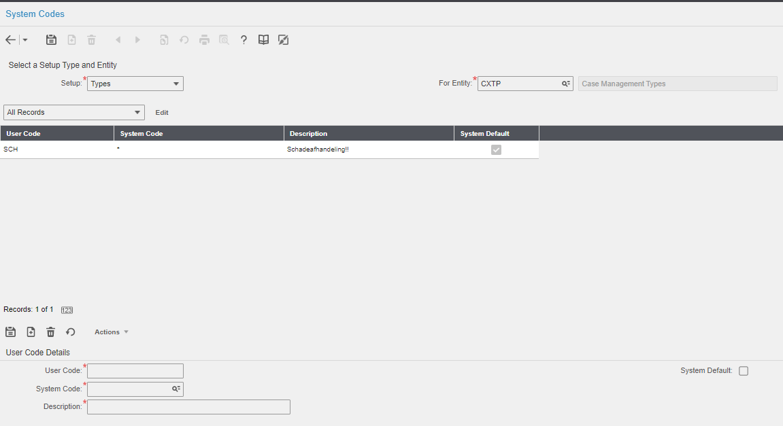

- Create Record :- Administrator→ Setup→ Cost code
Screen:- BSCSTC

Costcode | Description
4406 | betaalde eigen risico (afas)
4407 | bedrag ontvangen (afas)
4405 | betaalde schade reparatie algemeen
4408 | betaalde schade reparatie spiegels
4409 | betaalde schade reparatie ruiten
4413 | Afsleepkosten
4580 | Schade gebouwen
4505 | Schade laadinfra

- Status Authorization: Administrator → Security → Status Authorization

User Group | User | Entity | From Status | To Status
VLOOT-MAN | * | EVNT | A | W

Save the record.
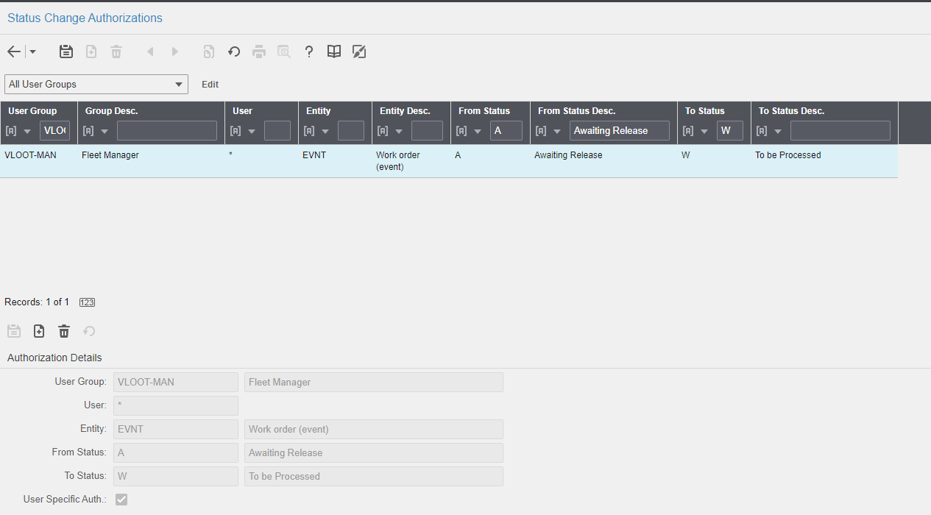

Contents List
The release is contained in compressed file, which contains the following files:
Db scripts
· SPC-296.sql

EF
- QBUZZ_external_WSJOBO.txt
- QBUZZ_external_WSTRAD.txt
- QBUZZ_external_SCHADE.txt

Release Note: Qbuzz_release0.0.8_EAM11.7-Qbuzz- New Changes_Release 12Dec

